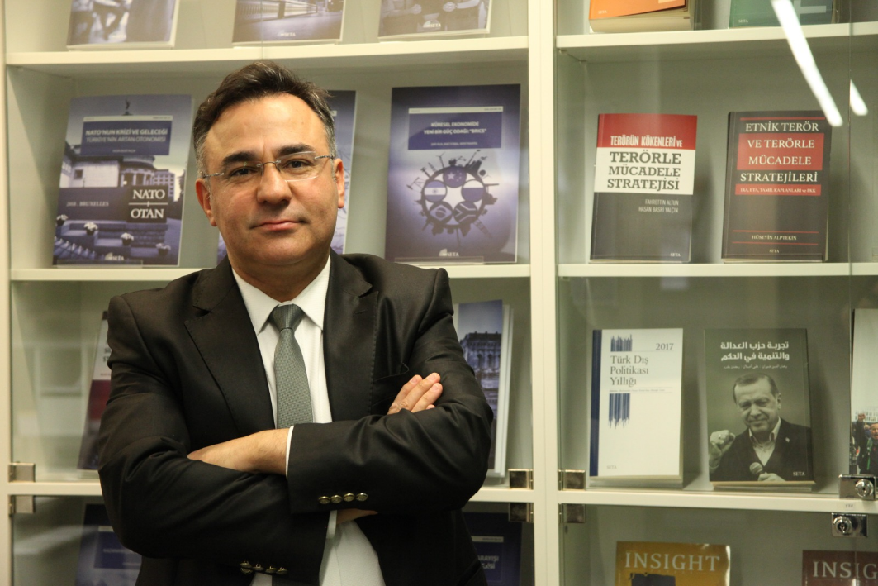**Assoc. Prof. Murat ASLAN**

Faculty Member of Hasan Kalyoncu University, SETA Researcher, Director of KALMEC

(Security, Defense, Foreign Policy)

He graduated from War College in the field of Management in 1991. He assumed varying tasks and appointments in the Turkish Armed Forces (TAF). He graduated with Master’s (2010) and Ph.D. programs (2017) in the International Relations Department of the Middle Eastern Technical University. He scrutinized the Chinese soft power practices through cultural diffusion efforts and African policy for a Master’s degree. His Ph. D. research was about intelligence and propaganda efforts in peace-oriented undertakings based on the UN and NATO practices in Bosnia and Afghanistan.

His studies are primarily on security and defense studies, the conceptualization of power, intelligence and propaganda practices. He had been commissioned to Iraq, Afghanistan, and Bosnia, facilitating the comparison of theory and practice when he was in Service. The primary region he has been interested in is the Middle East; he had monitored wider Afghanistan, the Balkans, the USA, and China as a secondary academic effort. He was a faculty member of the Istanbul Sabahattin Zaim University of Turkey after teaching as a visiting scholar at Başkent University. He is currently a faculty member at Hasan Kalyoncu University and a Researcher at SETA Foundation. Meanwhile, he is the director of the Kalyoncu Middle East Center.

Aslan is the author of the books - *Security Sector Reform for Libya: A Crucial Step Towards State Building*, *Intelligence and Propaganda: The Cases of Bosnia and Herzegovina and Afghanistan*, other than academic articles. He edited the books *Afghanistan: the Hundred Years’ Crisis* (with Prof. Ramazan Erdag) and *Turkiye’s Counter Terrorism: Concept, Procedures, and Methodology*.

e-mail: [murat.aslan@hku.edu.tr](mailto:murat.aslan@hku.edu.tr)